Practical No 1

Aim: create an android application to add 2 no and display values on button click

Description:

Android

Android is a mobile operating system that is based on linux modified version.It is developed by google.It is primarily design for tablets ,smartphones,touchscreen mobile devices.

Features

1. Storage: uses SQLite a light relational database for storage
2. Messaging: supports both SMS and MMS
3. Connectivity: Supports Bluetooth ,WiFi
4. MultiTouch: Supports multitouch screen
5. Media Support: Supports media like PNG,GIF,MP3,JPEG

Activity:

A basic unit of android application .An Activty displays UI of your Application which may contain widgets like button,labesl,textviews We define UI by using XML file

During Runtime you have to load your UI in the onCreate() method in MainActivity using setContentView(R.layout.activity_main)

Layout:

Different layout use in android

1. Linear layout: This layout arranges the view in single row or a single column
2. Relative layout: Android RelativeLayout enables you to specify how child views are positioned relative to each other. The position of each view can be specified as relative to sibling elements or relative to the parent
3. AbsoluteLayout: It enables you to specify the exact location of its children( (x/y coordinates).
4. TableLayout :this layout going to be arranged groups of views into rows and columns

Program

MainActivity.java

**import** android.support.v7.app.AppCompatActivity;  
**import** android.os.Bundle;  
**import** android.view.View;  
**import** android.widget.Button;  
**import** android.widget.TextView;  
  
**public class** MainActivity **extends** AppCompatActivity {  
 Button **b**;  
 TextView **v1**,**v2**,**v3**;  
 @Override  
**protected void** onCreate(Bundle savedInstanceState) {  
**super**.onCreate(savedInstanceState);  
 setContentView(R.layout.***activity_main***);  
**b**=(Button)findViewById(R.id.***button***);  
**v1**=(TextView)findViewById(R.id.***editText***);  
**v2**=(TextView)findViewById(R.id.***editText2***);  
**v3**=(TextView)findViewById(R.id.***editText3***);  
**b**.setOnClickListener(**new** View.OnClickListener()  
 {  
**public void** onClick(View v)  
 {  
**int** value=Integer.*parseInt*(**v1**.getText().toString());  
**int** value1=Integer.*parseInt*(**v2**.getText().toString());  
**int** value3=value1+value;  
 String s=String.*valueOf*(value3);  
**v3**.setText(s);  
 }  
 });  
 }  
}

activity_main.xml

*<?***xml version="1.0" encoding="utf-8"***?>*<**RelativeLayout xmlns:android="http://schemas.android.com/apk/res/android"  
 xmlns:app="http://schemas.android.com/apk/res-auto"  
 xmlns:tools="http://schemas.android.com/tools"  
 android:layout_width="match_parent"  
 android:layout_height="match_parent"  
 tools:context="com.example.rajesh.form.MainActivity"**>  
  
<**TextView  
 android:id="@+id/textView"  
 android:layout_width="wrap_content"  
 android:layout_height="wrap_content"  
 android:layout_alignParentLeft="true"  
 android:layout_alignParentStart="true"  
 android:layout_alignParentTop="true"  
 android:layout_marginLeft="40dp"  
 android:layout_marginStart="40dp"  
 android:layout_marginTop="36dp"  
 android:text="Enter first number"** />  
  
<**EditText  
 android:id="@+id/editText"  
 android:layout_width="wrap_content"  
 android:layout_height="wrap_content"  
 android:ems="10"  
 android:inputType="textPersonName"  
 android:text=""  
 android:layout_alignBaseline="@+id/textView"  
 android:layout_alignBottom="@+id/textView"  
 android:layout_toRightOf="@+id/textView"  
 android:layout_toEndOf="@+id/textView"  
 android:layout_marginLeft="27dp"  
 android:layout_marginStart="27dp"** />  
  
<**TextView  
 android:id="@+id/textView2"  
 android:layout_width="wrap_content"  
 android:layout_height="wrap_content"  
 android:layout_below="@+id/editText"  
 android:layout_marginTop="31dp"  
 android:layout_toLeftOf="@+id/editText"  
 android:layout_toStartOf="@+id/editText"  
 android:text="Enter second Number"** />  
  
<**EditText  
 android:id="@+id/editText2"  
 android:layout_width="wrap_content"  
 android:layout_height="wrap_content"  
 android:layout_below="@+id/editText"  
 android:layout_marginLeft="31dp"  
 android:layout_marginStart="31dp"  
 android:layout_marginTop="16dp"  
 android:layout_toEndOf="@+id/textView2"  
 android:layout_toRightOf="@+id/textView2"  
 android:ems="10"  
 android:inputType="textPersonName"  
 android:text=""** />  
  
<**TextView  
 android:id="@+id/textView3"  
 android:layout_width="wrap_content"  
 android:layout_height="wrap_content"  
 android:text="Result"  
 android:layout_alignBaseline="@+id/editText3"  
 android:layout_alignBottom="@+id/editText3"  
 android:layout_alignLeft="@+id/textView"  
 android:layout_alignStart="@+id/textView"  
 android:layout_marginLeft="28dp"  
 android:layout_marginStart="28dp"** />  
  
<**EditText  
 android:id="@+id/editText3"  
 android:layout_width="wrap_content"  
 android:layout_height="wrap_content"  
 android:layout_alignLeft="@+id/editText"  
 android:layout_alignStart="@+id/editText"  
 android:layout_below="@+id/editText2"  
 android:layout_marginTop="22dp"  
 android:ems="10"  
 android:inputType="textPersonName"  
 android:text=""** />  
  
<**Button  
 android:id="@+id/button"  
 android:layout_width="wrap_content"  
 android:layout_height="wrap_content"  
 android:layout_centerVertical="true"  
 android:layout_marginLeft="15dp"  
 android:layout_marginStart="15dp"  
 android:layout_toEndOf="@+id/textView3"  
 android:layout_toRightOf="@+id/textView3"  
 android:text="calculate"** />  
</**RelativeLayout**>

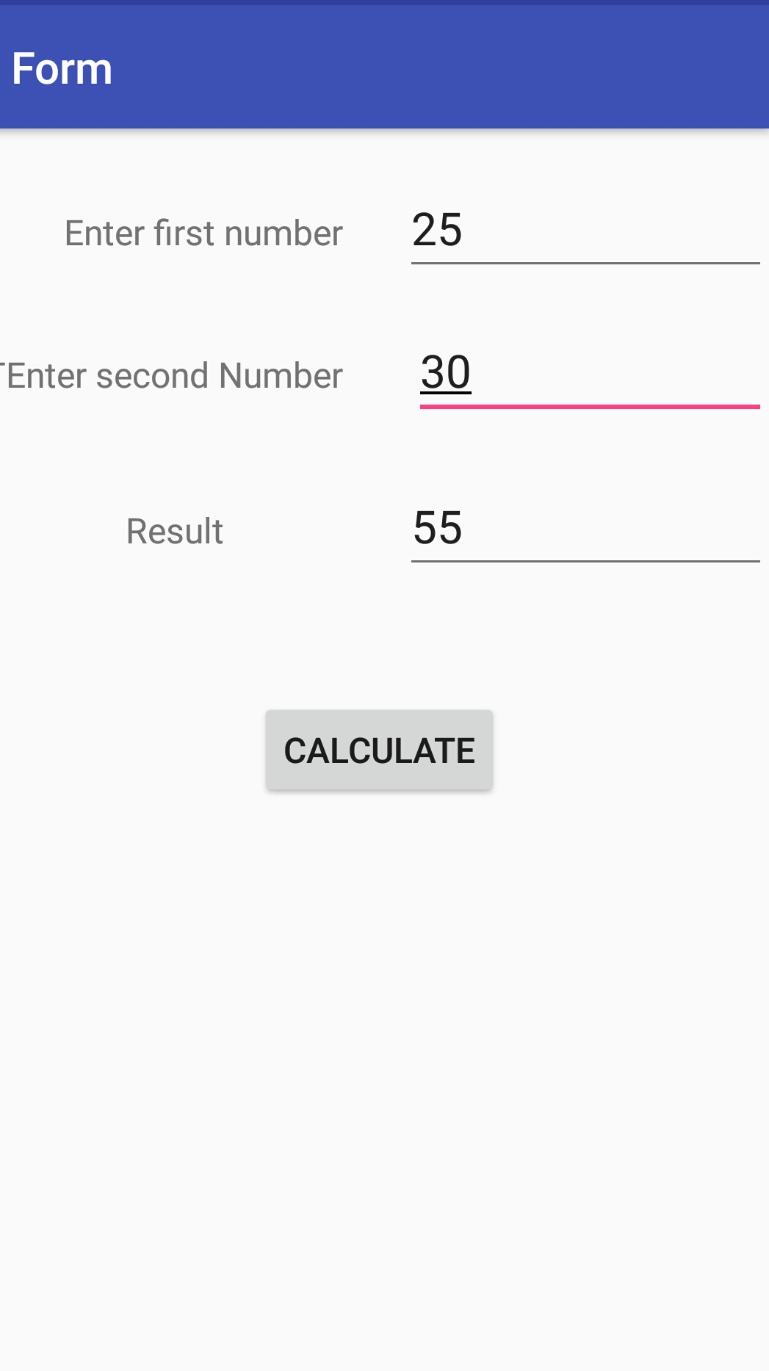

Practical No 2

Aim: create an android application for registration form with name,contact,gender and hobbies and display into message box.

Description:

Text View:

* A **TextView** displays **text** to the user and optionally allows them to edit it.
* TextView attributes
  + Id: the ID uniquely identifies the control.
  + inputType:type of data being placed in textfield .date,time,number,password
  + android:text: contain text to display

Button:

* Android Button represents a push-button which can be pressed, or clicked, by the user to perform an action.
* Button attributes
* Id: it uniquely identifies the control
* text : specifies the text to display over the button
* onClick: name of the method to be invoked when button is clicked

RadioButton and RadioGroup

* The RadioButton has two states: either checked or unchecked.
* A RadioGroup is used to group together one or more RadioButton views, If we check one radio button that belongs to a radio group, it automatically unchecks any previously checked radio button within the same group.
* RadioButton Attributes
* Id: it uniquely identifies the control
* Text: specifies the text to be displayed
* checked: specifies whether the checkbox is checked or not

checkbox

* A special type of button that has two states: checked or unchecked
* CheckBox Attributes
* Id: it uniquely identifies the control
* Text: specifies the text to be displayed
* checked: specifies whether the checkbox is checked or not

Program

MainActivity.java

**package** com.example.rajesh.form;  
  
**import** android.support.v7.app.AppCompatActivity;  
**import** android.os.Bundle;  
**import** android.view.View;  
**import** android.widget.Button;  
**import** android.widget.CheckBox;  
**import** android.widget.RadioButton;  
**import** android.widget.RadioGroup;  
**import** android.widget.TextView;  
**import** android.widget.Toast;  
  
**public class** MainActivity **extends** AppCompatActivity {  
 Button **b**;  
 TextView **v1**,**v2**;  
 String **s**,**s1**,**s2**;  
  
 RadioGroup **rdg**;  
 RadioButton **r1**,**r2**;  
 CheckBox **cb1**,**cb2**,**cb3**,**cb4**;  
  
 @Override  
**protected void** onCreate(Bundle savedInstanceState) {  
**super**.onCreate(savedInstanceState);  
 setContentView(R.layout.***activity_main***);  
**b**=(Button)findViewById(R.id.***button1***);  
**v1**=(TextView)findViewById(R.id.***editText1***);  
**v2**=(TextView)findViewById(R.id.***editText2***);  
**rdg**=(RadioGroup)findViewById(R.id.***radiogroup***);  
  
**cb1**=(CheckBox)findViewById(R.id.***checkBox1***);  
**cb2**=(CheckBox)findViewById(R.id.***checkBox2***);  
**cb3**=(CheckBox)findViewById(R.id.***checkBox3***);  
**cb4**=(CheckBox)findViewById(R.id.***checkBox4***);  
  
**b**.setOnClickListener(**new** View.OnClickListener()  
 {  
**public void** onClick(View v)  
 {  
**s1**= **v1**.getText().toString();  
**s2**=**v2**.getText().toString();  
**int** selectedId = **rdg**.getCheckedRadioButtonId();  
 RadioButton r3 = (RadioButton) findViewById(selectedId);  
**s**=r3.getText().toString();  
 String h=**""**;  
**if**(**cb1**.isChecked()){  
 h+=**cb1**.getText().toString();  
 }  
**if**(**cb2**.isChecked()){  
 h+=**cb2**.getText().toString();  
 }  
**if**(**cb3**.isChecked()){  
 h+=**cb3**.getText().toString();  
 }  
**if**(**cb4**.isChecked()){  
 h+=**cb4**.getText().toString();  
 }  
  
 String data=**"name="**+**s1**+**",Contact_no="**+**s2**+**",gender="**+**s**+**",hobbies="**+ h;  
 Toast.*makeText*(MainActivity.**this**,**"Biodata="**+data,Toast.***LENGTH_SHORT***).show();  
  
 }  
 });  
 }  
}

activity_main.xml

*<?***xml version="1.0" encoding="utf-8"***?>*<**RelativeLayout xmlns:android="http://schemas.android.com/apk/res/android"  
 xmlns:app="http://schemas.android.com/apk/res-auto"  
 xmlns:tools="http://schemas.android.com/tools"  
 android:layout_width="match_parent"  
 android:layout_height="match_parent"  
 tools:context="com.example.rajesh.form.MainActivity"**>  
  
  
<**TextView  
 android:id="@+id/textView1"  
 android:layout_width="wrap_content"  
 android:layout_height="wrap_content"  
 android:layout_alignParentLeft="true"  
 android:layout_alignParentStart="true"  
 android:layout_alignParentTop="true"  
 android:layout_marginLeft="27dp"  
 android:layout_marginStart="27dp"  
 android:layout_marginTop="29dp"  
 android:text="Name"** />  
  
<**EditText  
 android:id="@+id/editText1"  
 android:layout_width="wrap_content"  
 android:layout_height="wrap_content"  
 android:layout_alignBaseline="@+id/textView1"  
 android:layout_alignBottom="@+id/textView1"  
 android:layout_marginLeft="39dp"  
 android:layout_marginStart="39dp"  
 android:layout_toEndOf="@+id/textView1"  
 android:layout_toRightOf="@+id/textView1"  
 android:ems="10"  
 android:inputType="textPersonName"** />  
  
<**TextView  
 android:id="@+id/textView2"  
 android:layout_width="wrap_content"  
 android:layout_height="wrap_content"  
 android:layout_marginTop="33dp"  
 android:text="ContactNo"  
 android:layout_below="@+id/editText1"  
 android:layout_alignParentLeft="true"  
 android:layout_alignParentStart="true"  
 android:layout_marginLeft="15dp"  
 android:layout_marginStart="15dp"** />  
  
<**EditText  
 android:id="@+id/editText2"  
 android:layout_width="wrap_content"  
 android:layout_height="wrap_content"  
 android:ems="10"  
 android:inputType="phone"  
 android:layout_alignBaseline="@+id/textView2"  
 android:layout_alignBottom="@+id/textView2"  
 android:layout_alignLeft="@+id/editText1"  
 android:layout_alignStart="@+id/editText1"** />  
  
<**TextView  
 android:id="@+id/textView3"  
 android:layout_width="wrap_content"  
 android:layout_height="wrap_content"  
 android:layout_alignLeft="@+id/textView1"  
 android:layout_alignStart="@+id/textView1"  
 android:layout_below="@+id/editText2"  
 android:layout_marginTop="30dp"  
 android:text="Gender "** />  
  
  
  
<**TextView  
 android:id="@+id/textView9"  
 android:layout_width="wrap_content"  
 android:layout_height="wrap_content"  
 android:layout_alignEnd="@+id/textView2"  
 android:layout_alignRight="@+id/textView2"  
 android:layout_below="@+id/textView3"  
 android:layout_marginTop="45dp"  
 android:text="Hobbies"** />  
  
<**CheckBox  
 android:id="@+id/checkBox1"  
 android:layout_width="wrap_content"  
 android:layout_height="wrap_content"  
 android:text="dancing"  
 android:layout_below="@+id/textView9"  
 android:layout_alignLeft="@+id/editText2"  
 android:layout_alignStart="@+id/editText2"** />  
  
<**CheckBox  
 android:id="@+id/checkBox2"  
 android:layout_width="wrap_content"  
 android:layout_height="wrap_content"  
 android:text="Singing"  
 android:layout_below="@+id/textView9"  
 android:layout_alignRight="@+id/editText2"  
 android:layout_alignEnd="@+id/editText2"  
 android:layout_marginRight="17dp"  
 android:layout_marginEnd="17dp"** />  
  
<**CheckBox  
 android:id="@+id/checkBox3"  
 android:layout_width="wrap_content"  
 android:layout_height="wrap_content"  
 android:layout_alignLeft="@+id/checkBox1"  
 android:layout_alignStart="@+id/checkBox1"  
 android:layout_below="@+id/checkBox1"  
 android:layout_marginTop="29dp"  
 android:text="Reading"** />  
  
<**CheckBox  
 android:id="@+id/checkBox4"  
 android:layout_width="wrap_content"  
 android:layout_height="wrap_content"  
 android:layout_alignBottom="@+id/checkBox3"  
 android:layout_alignLeft="@+id/checkBox2"  
 android:layout_alignStart="@+id/checkBox2"  
 android:text="Cricket"** />  
  
<**Button  
 android:id="@+id/button1"  
 android:layout_width="wrap_content"  
 android:layout_height="wrap_content"  
 android:layout_below="@+id/checkBox3"  
 android:layout_centerHorizontal="true"  
 android:layout_marginTop="79dp"  
 android:text="Submit"** />  
<**RadioGroup  
 android:id="@+id/radiogroup"  
 android:layout_width="wrap_content"  
 android:layout_height="wrap_content"  
 android:orientation="horizontal"  
 android:layout_marginRight="12dp"  
 android:layout_marginEnd="12dp"  
 android:layout_alignTop="@+id/textView3"  
 android:layout_alignRight="@+id/checkBox4"  
 android:layout_alignEnd="@+id/checkBox4"**>  
  
  
<**RadioButton  
 android:id="@+id/radioButton3"  
 android:layout_width="wrap_content"  
 android:layout_height="wrap_content"  
 android:text="Male"  
 android:layout_alignTop="@+id/textView3"  
 android:layout_alignRight="@+id/checkBox4"  
 android:layout_alignEnd="@+id/checkBox4"** />  
  
<**RadioButton  
 android:id="@+id/radioButton2"  
 android:layout_width="wrap_content"  
 android:layout_height="wrap_content"  
 android:layout_alignBaseline="@+id/radioButton3"  
 android:layout_alignBottom="@+id/radioButton3"  
 android:layout_marginEnd="18dp"  
 android:layout_marginRight="18dp"  
 android:layout_toLeftOf="@+id/radioButton3"  
 android:layout_toStartOf="@+id/radioButton3"  
 android:text="Female"** />  
</**RadioGroup**>  
</**RelativeLayout**>

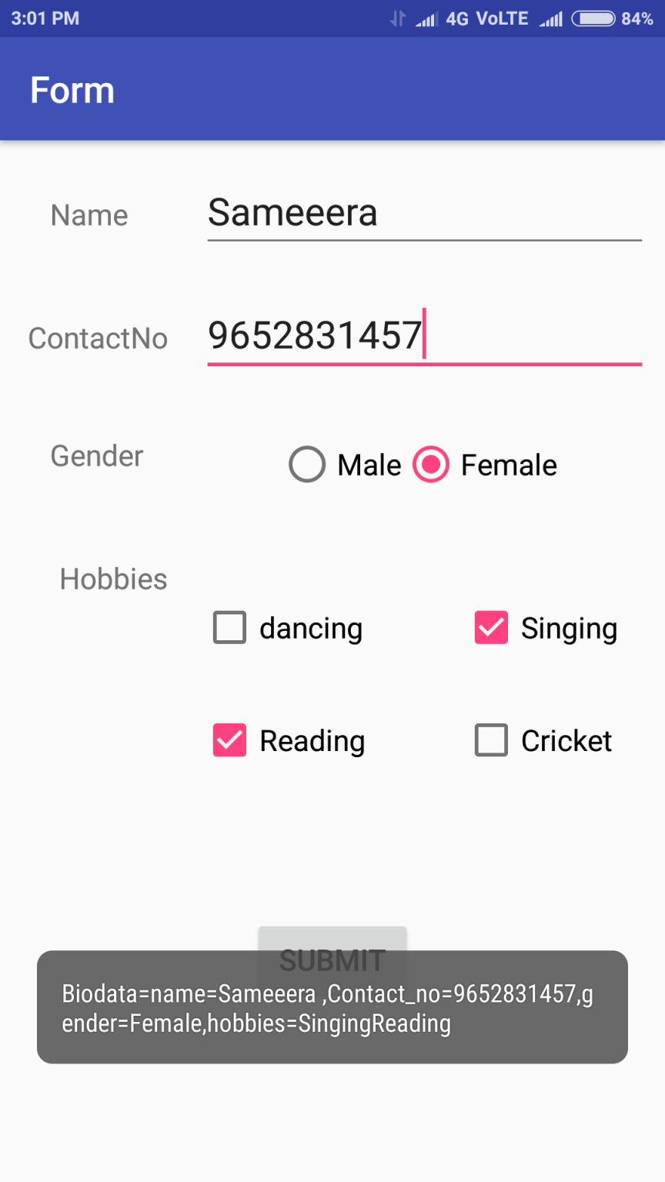

Practical No 3

Aim: Create an android Application to demonstrate the Spinner and ListView View

Description:

1. ListeView View

* Android **ListView** is a view which contains the group of items and displays in a scrollable list.
* The list items are automatically inserted to the list using an **Adapter** that pulls content from a source such as an array or database.
* Adapter holds the data and send the data to adapter view, the view can takes the data from adapter view and shows the data on different views like as spinner, list view, grid view etc.
* ListView Attributes

-id: specifies the id ,that uniquely identify the view

- entries: specifies the reference to an array resource that will fill the ListView

* ListeView methods

setChoiceMode(int n) – this method specify the no of items to be selected a t time from list view

1. Spinner View

* **Android Spinner** is like the combox box of AWT or Swing. It can be used to display the multiple options to the user in which only one item can be selected by the user.
* Android spinner is like the drop down menu with multiple values from which the end user can select only one value.
* Android spinner is associated with AdapterView. So you need to use one of the adapter classes with spinner.

Program

a)ListView

activity_main.xml

*<?***xml version="1.0" encoding="utf-8"***?>*<**RelativeLayout xmlns:android="http://schemas.android.com/apk/res/android"  
 xmlns:app="http://schemas.android.com/apk/res-auto"  
 xmlns:tools="http://schemas.android.com/tools"  
 android:layout_width="match_parent"  
 android:layout_height="match_parent"  
 tools:context="com.example.rajesh.form.MainActivity"**>  
  
  
<**ListView  
 android:id="@+id/list"  
 android:layout_width="match_parent"  
 android:layout_height="match_parent"  
 android:layout_alignParentTop="true"** />  
</**RelativeLayout**>

MainActivity.java

**package** com.example.rajesh.form;  
  
**import** android.graphics.Color;  
**import** android.support.v7.app.AppCompatActivity;  
**import** android.os.Bundle;  
**import** android.util.Log;  
**import** android.view.Menu;  
**import** android.view.View;  
**import** android.widget.ArrayAdapter;  
**import** android.widget.AutoCompleteTextView;  
**import** android.widget.Button;  
**import** android.widget.CheckBox;  
**import** android.widget.ListView;  
**import** android.widget.RadioButton;  
**import** android.widget.RadioGroup;  
**import** android.widget.TextView;  
**import** android.widget.Toast;  
  
**public class** MainActivity **extends** AppCompatActivity {  
  
  
  
 @Override  
**protected void** onCreate(Bundle savedInstanceState) {  
**super**.onCreate(savedInstanceState);  
 setContentView(R.layout.***activity_main***);  
 String s[]={**"C"**,**"C++"**,**"JAVA"**,**"PYTHON"**,**"ANDROID"**,**"PLSQL"**,**"ASP.NET"**,**"PHP"**,**"HTML"**};  
 ArrayAdapter<String> a=**new** ArrayAdapter<String>(**this**,android.R.layout.***simple_list_item_1***,s);  
 ListView lt=(ListView)findViewById(R.id.***list***);  
 lt.setAdapter(a);  
 lt.setChoiceMode(2);  
  
  
 }  
  
  
}

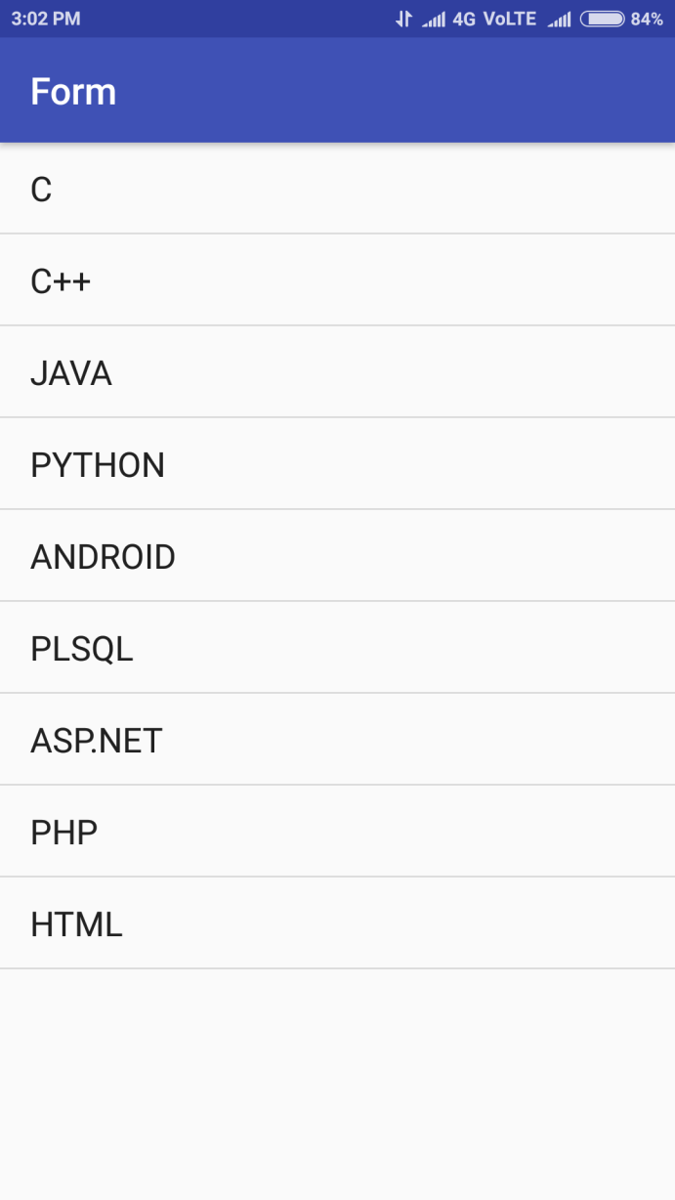

b)Spinner

activity_main.xml

*<?***xml version="1.0" encoding="utf-8"***?>*<**RelativeLayout xmlns:android="http://schemas.android.com/apk/res/android"  
 xmlns:app="http://schemas.android.com/apk/res-auto"  
 xmlns:tools="http://schemas.android.com/tools"  
 android:layout_width="match_parent"  
 android:layout_height="match_parent"  
 tools:context="com.example.rajesh.form.MainActivity"**>  
  
  
<**Spinner  
 android:id="@+id/spinner"  
 android:layout_width="match_parent"  
 android:layout_height="wrap_content"  
 android:layout_alignParentLeft="true"  
 android:layout_alignParentStart="true"  
 android:layout_alignParentTop="true"  
 android:layout_marginLeft="47dp"  
 android:layout_marginStart="47dp"  
 android:layout_marginTop="125dp"** />  
</**RelativeLayout**>

MainActivity.java

**package** com.example.rajesh.form;  
  
**import** android.graphics.Color;  
**import** android.support.v7.app.AppCompatActivity;  
**import** android.os.Bundle;  
**import** android.util.Log;  
**import** android.view.Menu;  
**import** android.view.View;  
**import** android.widget.ArrayAdapter;  
**import** android.widget.AutoCompleteTextView;  
**import** android.widget.Button;  
**import** android.widget.CheckBox;  
**import** android.widget.ListView;  
**import** android.widget.RadioButton;  
**import** android.widget.RadioGroup;  
**import** android.widget.Spinner;  
**import** android.widget.TextView;  
**import** android.widget.Toast;  
  
**public class** MainActivity **extends** AppCompatActivity {  
  
  
  
 @Override  
**protected void** onCreate(Bundle savedInstanceState) {  
**super**.onCreate(savedInstanceState);  
 setContentView(R.layout.***activity_main***);  
 String s[]={**"C"**,**"C++"**,**"JAVA"**,**"PYTHON"**,**"ANDROID"**,**"PLSQL"**,**"ASP.NET"**,**"PHP"**,**"HTML"**};  
 ArrayAdapter<String> a=**new** ArrayAdapter<String>(**this**,android.R.layout.***simple_spinner_item***,s);  
 Spinner lt=(Spinner) findViewById(R.id.***spinner***);  
 lt.setAdapter(a);  
  
  
  
 }  
  
  
}

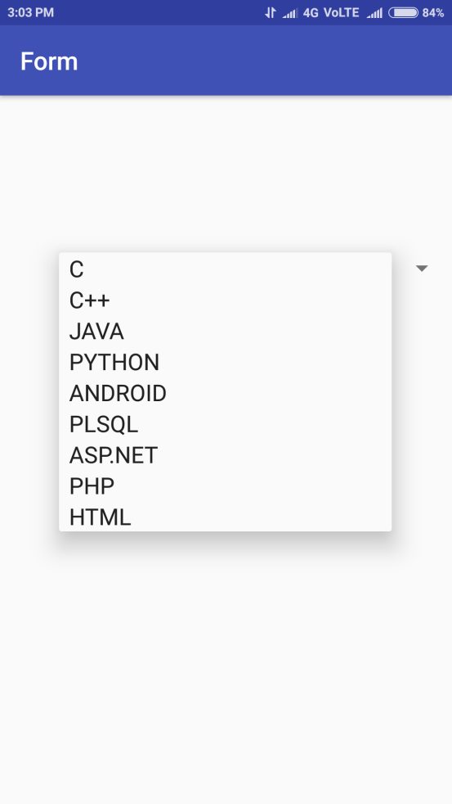

Practical No 4

Aim: create a android application to demonstrate AutoCompleteTextView

Description:

* **Android AutoCompleteTextView** completes the word based on the reserved words, so no need to write all the characters of the word.
* Android AutoCompleteTextView is a editable text field, it displays a list of suggestions in a drop down menu from which user can select only one suggestion or value.
* In this example, we are displaying the programming languages in the autocompletetextview. All the programming languages are stored in string array. We are using the **ArrayAdapter** class to display the array content.
* The ArrayAdapter object manages the array of strings that will be displayed by the AutoCompleteTextView
* The setThreshold() method sets the minimum number of characters the user must type before the suggestions appear as a drop-down menu:
* The list of suggestions to display for the AutoCompleteTextView is obtained from the ArrayAdapter object: textView.setAdapter(adapter);
* setContentView()=display the Layout created thorugh XML or the Dynamically created layout view in the Screen.

program

Activity_main.xml

*<?***xml version="1.0" encoding="utf-8"***?>*<**RelativeLayout xmlns:android="http://schemas.android.com/apk/res/android"  
 xmlns:app="http://schemas.android.com/apk/res-auto"  
 xmlns:tools="http://schemas.android.com/tools"  
 android:layout_width="match_parent"  
 android:layout_height="match_parent"  
 tools:context="com.example.rajesh.form.MainActivity"**>  
  
  
<**TextView  
 android:id="@+id/textView"  
 android:layout_width="wrap_content"  
 android:layout_height="wrap_content"  
 android:layout_alignParentLeft="true"  
 android:layout_alignParentStart="true"  
 android:layout_alignParentTop="true"  
 android:layout_marginLeft="149dp"  
 android:layout_marginStart="149dp"  
 android:layout_marginTop="68dp"  
 android:text="TextView"** />  
  
<**AutoCompleteTextView  
 android:id="@+id/autoCompleteTextView"  
 android:layout_width="match_parent"  
 android:layout_height="wrap_content"  
 android:text=""  
 android:layout_marginTop="21dp"  
 android:layout_below="@+id/textView"  
 android:layout_centerHorizontal="true"** />  
  
</**RelativeLayout**>

MainActivity.java

**package** com.example.rajesh.form;  
  
**import** android.graphics.Color;  
**import** android.support.v7.app.AppCompatActivity;  
**import** android.os.Bundle;  
**import** android.view.Menu;  
**import** android.view.View;  
**import** android.widget.ArrayAdapter;  
**import** android.widget.AutoCompleteTextView;  
**import** android.widget.Button;  
**import** android.widget.CheckBox;  
**import** android.widget.RadioButton;  
**import** android.widget.RadioGroup;  
**import** android.widget.TextView;  
**import** android.widget.Toast;  
  
**public class** MainActivity **extends** AppCompatActivity {  
  
AutoCompleteTextView**at**;  
  
 @Override  
**protected void** onCreate(Bundle savedInstanceState) {  
**super**.onCreate(savedInstanceState);  
 setContentView(R.layout.***activity_main***);

String s[]={**"C"**,**"C++"**,**"JAVA"**,**"PYTHON"**,**"ANDROID"**,**"PLSQL"**,**"ASP.NET"**,

**"PHP"**,**"HTML"**};  
**at** = (AutoCompleteTextView) findViewById(R.id.***autoCompleteTextView***);  
 ArrayAdapter<String> a= **new** ArrayAdapter<String>(**this**,android.R.layout.***select_dialog_item***,s);  
**at**.setThreshold(2);  
**at**.setAdapter(a);  
**at**.setTextColor(Color.***RED***);  
 }  
  
}

Practical No 5

Aim: create an android application program to demonstrate the Activity Life cycle

Description:

* The Activity class defines the following events:
* onCreate()➤➤ — Called when the activity is first created . In the [onCreate()](https://developer.android.com/reference/android/app/Activity.html#onCreate%28android.os.Bundle%29) method, you perform basic application startup logic that should happen only once for the entire life of the activity
* onStart()➤➤ — Called when the activity becomes visible to the user. For example, this method is where the app initializes the code that maintains the UI
* onResume()➤➤ — Called when the activity starts interacting with the user . Such an event might be, for instance, receiving a phone call, the user’s navigating to another activity, or the device screen’s turning off.
* onPause()➤➤ — Called when the current activity is being paused and the previous activity is being resumed
* onStop()➤➤ — Called when the activity is no longer visible to the user for The system may also call [onStop()](https://developer.android.com/reference/android/app/Activity.html#onStop%28%29) when the activity has finished running, and is about to be terminated
* onDestroy()➤➤ — Called before the activity is destroyed by the system
* onRestart()➤➤ — Called when the activity has been stopped and is restarting again

Program

MainActivity.java

**package** com.example.rajesh.form;  
  
**import** android.graphics.Color;  
**import** android.support.v7.app.AppCompatActivity;  
**import** android.os.Bundle;  
**import** android.util.Log;  
**import** android.view.Menu;  
**import** android.view.View;  
**import** android.widget.ArrayAdapter;  
**import** android.widget.AutoCompleteTextView;  
**import** android.widget.Button;  
**import** android.widget.CheckBox;  
**import** android.widget.RadioButton;  
**import** android.widget.RadioGroup;  
**import** android.widget.TextView;  
**import** android.widget.Toast;  
  
**public class** MainActivity **extends** AppCompatActivity {  
 @Override  
**protected void** onCreate(Bundle savedInstanceState) {  
**super**.onCreate(savedInstanceState);  
 setContentView(R.layout.***activity_main***);  
  
  
 }  
  
 @Override  
**protected void** onStart() {  
**super**.onStart();  
 Log.*d*(**"lifecycle"**,**"onStart invoked"**);  
 }  
 @Override  
**protected void** onResume() {  
**super**.onResume();  
 Log.*d*(**"lifecycle"**,**"onResume invoked"**);  
 }  
 @Override  
**protected void** onPause() {  
**super**.onPause();  
 Log.*d*(**"lifecycle"**,**"onPause invoked"**);  
 }  
 @Override  
**protected void** onStop() {  
**super**.onStop();  
 Log.*d*(**"lifecycle"**,**"onStop invoked"**);  
 }  
 @Override  
**protected void** onRestart() {  
**super**.onRestart();  
 Log.*d*(**"lifecycle"**,**"onRestart invoked"**);  
 }  
 @Override  
**protected void** onDestroy() {  
**super**.onDestroy();  
 Log.*d*(**"lifecycle"**,**"onDestroy invoked"**);  
 }  
}

Practical No 6

Aim: Create anandroid application to transfer data from one intent to another intent

Description:

* Intents are asynchronous messages which allow application components to request functionality from other Android components. Intents allow you to interact with components from the same applications as well as with components contributed by other applications. For example, an activity can start an external activity for taking a picture.
* Activities which are started by other Android activities are called sub-activities. This wording makes it easier to describe which activity is meant.
* The following code demonstrates how you can start another activity via an intent.

**Intent** i = **new**Intent(this, ActivityTwo.class);

startActivity(i);

* The [Intent](https://developer.android.com/reference/android/content/Intent.html) constructor takes two parameters:
  + A [Context](https://developer.android.com/reference/android/content/Context.html) as its first parameter (this is used because the [Activity](https://developer.android.com/reference/android/app/Activity.html) class is a subclass of [Context](https://developer.android.com/reference/android/content/Context.html))
  + The [Class](https://developer.android.com/reference/java/lang/Class.html) of the app component to which the system should deliver the [Intent](https://developer.android.com/reference/android/content/Intent.html) (in this case, the activity that should be started).
* The [startActivity()](https://developer.android.com/reference/android/app/Activity.html#startActivity%28android.content.Intent%29) method starts an instance of the DisplayMessageActivity specified by the [Intent](https://developer.android.com/reference/android/content/Intent.html). Now you need to create that class.

Program

activity_main.xml

*<?***xml version="1.0" encoding="utf-8"***?>*<**RelativeLayout xmlns:android="http://schemas.android.com/apk/res/android"  
 xmlns:app="http://schemas.android.com/apk/res-auto"  
 xmlns:tools="http://schemas.android.com/tools"  
 android:layout_width="match_parent"  
 android:layout_height="match_parent"  
 android:orientation="vertical"  
 tools:context="com.example.rajesh.inentexample.MainActivity"**>  
  
<**TextView  
 android:layout_width="wrap_content"  
 android:layout_height="wrap_content"  
 android:text="Name"  
 app:layout_constraintBottom_toBottomOf="parent"  
 app:layout_constraintLeft_toLeftOf="parent"  
 app:layout_constraintRight_toRightOf="parent"  
 app:layout_constraintTop_toTopOf="parent"  
 android:layout_marginLeft="26dp"  
 android:layout_marginStart="26dp"  
 android:layout_marginTop="59dp"  
 android:id="@+id/textView"  
 android:layout_alignParentTop="true"  
 android:layout_alignParentLeft="true"  
 android:layout_alignParentStart="true"** />  
  
  
<**EditText  
 android:id="@+id/editText"  
 android:layout_width="wrap_content"  
 android:layout_height="wrap_content"  
 android:layout_above="@+id/button2"  
 android:layout_alignLeft="@+id/button2"  
 android:layout_alignStart="@+id/button2"  
 android:layout_marginLeft="31dp"  
 android:layout_marginStart="31dp"  
 android:ems="10"  
 android:inputType="textPersonName"  
 android:text=""** />  
  
<**Button  
 android:id="@+id/button2"  
 android:layout_width="wrap_content"  
 android:layout_height="wrap_content"  
 android:layout_marginTop="131dp"  
 android:text="Submit"  
 android:layout_below="@+id/textView"  
 android:layout_centerHorizontal="true"** />  
  
</**RelativeLayout**>

MainActivity.java

**package** com.example.rajesh.inentexample;  
  
**import** android.content.Intent;  
**import** android.support.v7.app.AppCompatActivity;  
**import** android.os.Bundle;  
**import** android.view.View;  
**import** android.widget.Button;  
**import** android.widget.EditText;  
**import** android.widget.TextView;  
  
**public class** MainActivity **extends** AppCompatActivity {  
 EditText **t1**;  
 Button **b1**;  
 @Override  
**protected void** onCreate(Bundle savedInstanceState) {  
**super**.onCreate(savedInstanceState);  
 setContentView(R.layout.***activity_main***);  
  
  
**b1**=(Button)findViewById(R.id.***button2***);  
**t1**=(EditText) findViewById(R.id.***editText***);  
**b1**.setOnClickListener(**new** View.OnClickListener()  
 {  
**public void** onClick(View view)  
 {  
 String name= String.*valueOf*(**t1**.getText());  
 Intent intent= **new** Intent(MainActivity.**this**,SecondActivity.**class**);  
 intent.putExtra(**"Data"**,name);  
 startActivity(intent);  
 }  
 });  
 }  
}

second.xml:

*<?***xml version="1.0" encoding="utf-8"***?>*<**RelativeLayout xmlns:android="http://schemas.android.com/apk/res/android"  
 android:orientation="vertical" android:layout_width="match_parent"  
 android:layout_height="match_parent"**>  
  
<**TextView  
 android:id="@+id/textView2"  
 android:layout_width="wrap_content"  
 android:layout_height="wrap_content"  
 android:text="Second Activity"** />  
</**RelativeLayout**>

SecondActivity.java

**package** com.example.rajesh.inentexample;  
  
**import** android.content.Intent;  
**import** android.os.Bundle;  
**import** android.support.v7.app.AppCompatActivity;  
**import** android.view.View;  
**import** android.widget.Button;  
**import** android.widget.TextView;  
**public class** SecondActivity **extends** AppCompatActivity {  
  
 @Override  
**protected void** onCreate(Bundle savedInstanceState) {  
**super**.onCreate(savedInstanceState);  
 setContentView(R.layout.***second***);  
 Intent intent=getIntent();  
 String str=intent.getExtras().getString(**"Data"**).toString();  
 TextView t;  
 t=(TextView)findViewById(R.id.***textView2***);  
  
 t.setText(**"Welcome To Computer Science "**+str);  
  
 }  
}

manifest file:

*<?***xml version="1.0" encoding="utf-8"***?>*<**manifest xmlns:android="http://schemas.android.com/apk/res/android"  
 package="com.example.rajesh.inentexample"**>  
  
<**application  
 android:allowBackup="true"  
 android:icon="@mipmap/ic_launcher"  
 android:label="@string/app_name"  
 android:roundIcon="@mipmap/ic_launcher_round"  
 android:supportsRtl="true"  
 android:theme="@style/AppTheme"**>  
<**activity android:name=".MainActivity"**>  
<**intent-filter**>  
<**action android:name="android.intent.action.MAIN"** />  
  
<**category android:name="android.intent.category.LAUNCHER"** />  
</**intent-filter**>  
</**activity**>

<!-- add this line --><**activity android:name=".SecondActivity"**/>  
</**application**>  
  
</**manifest**>

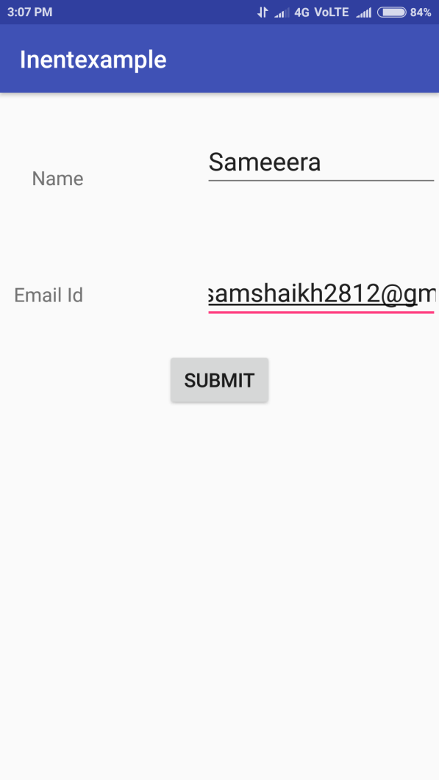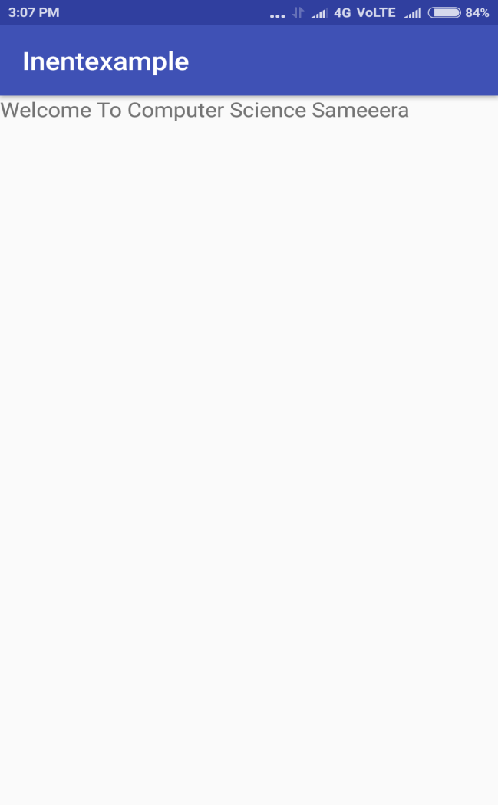

Practical No 7

Aim: Create an android application to create an option menu

Description:

* **Android Option Menus** are the primary menus of android.
* Menus are useful for displaying additional options that are not directly visible on the main UI of an application.
* They can be used for settings, search, delete item etc.
* To define the menu, create an XML file inside your project's res/menu/ directory and build the menu with the following elements:
* <menu>

Defines a [Menu](https://developer.android.com/reference/android/view/Menu.html), which is a container for menu items. A <menu> element must be the root node for the file and can hold one or more <item> and <group> elements.

* <item>

Creates a [MenuItem](https://developer.android.com/reference/android/view/MenuItem.html), which represents a single item in a menu. This element may contain a nested <menu> element in order to create a submenu

* Attributes:

1. android:id --A resource ID that's unique to the item, which allows the application to recognize the item when the user selects it.
2. android:icon--A reference to a drawable to use as the item's icon.
3. android:title--A reference to a string to use as the item's title./specifies the itme title

Program:

option Menu:

create a menu folder

res->Right click->New -> directory ->menu

Menu->right click->new resource file->menu1.xml

menu1.xml

<**menu xmlns:android="http://schemas.android.com/apk/res/android"**>  
<**item android:id="@+id/about"  
  
 android:title="About"** />  
<**item android:id="@+id/help"  
 android:title="Help"** />  
</**menu**>

MainActivity.java

**package** com.example.rajesh.form;  
  
**import** android.content.DialogInterface;  
**import** android.graphics.Color;  
**import** android.support.v7.app.AlertDialog;  
**import** android.support.v7.app.AppCompatActivity;  
**import** android.os.Bundle;  
**import** android.util.Log;  
**import** android.view.Menu;  
**import** android.view.MenuItem;  
**import** android.view.View;  
**import** android.widget.ArrayAdapter;  
**import** android.widget.AutoCompleteTextView;  
**import** android.widget.Button;  
**import** android.widget.CheckBox;  
**import** android.widget.ListView;  
**import** android.widget.RadioButton;  
**import** android.widget.RadioGroup;  
**import** android.widget.Spinner;  
**import** android.widget.TextView;  
**import** android.widget.Toast;  
  
**public class** MainActivity **extends** AppCompatActivity {  
  
  
  
 @Override  
**protected void** onCreate(Bundle savedInstanceState) {  
**super**.onCreate(savedInstanceState);  
 setContentView(R.layout.***activity_main***);  
  
  
  
  
 }  
 @Override  
**public boolean** onCreateOptionsMenu(Menu menu) {  
*// Inflate the menu; this adds items to the action bar if it is present.*getMenuInflater().inflate(R.menu.***menu1***, menu);*//Menu Resource, Menu***return true**;  
 }  
**public boolean** onOptionsItemSelected(MenuItem item) {  
**switch** (item.getItemId()) {  
**case** R.id.***about***:  
 Toast.*makeText*(this, **"Item 1 Selected"**, Toast.***LENGTH_LONG***).show();  
**return true**;  
**case** R.id.***help***:  
 Toast.*makeText*(this, **"Item 2 Selected"**, Toast.***LENGTH_LONG***).show();  
**return true**;  
  
**default**:  
**return true**  
 }  
  
 }  
 }

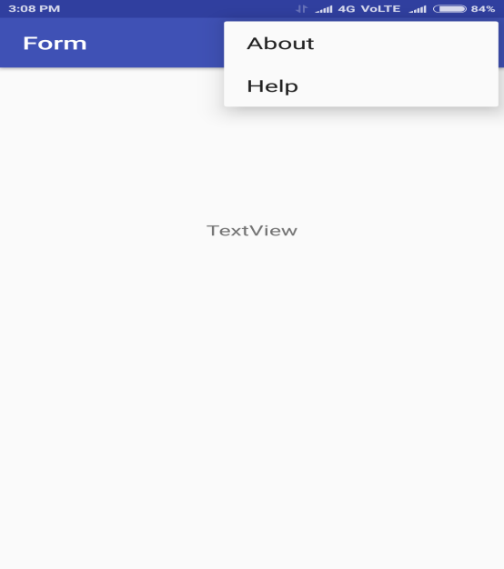

Practical No 8

Aim: Create an android application to show notification

Description:

1. A notification is a message your app displays to the user outside your application's normal UI. To see the details of the notification, the user opens the notification drawer, or views the notification on the lock screen if the device is locked
2. You have simple way to create a notification. Follow the following steps in your application to create a notification −

### Step 1 - Create Notification Builder

NotificationCompat.Builder mBuilder =newNotificationCompat.Builder(this)

### Step 2 - Setting Notification Properties

* A small icon, set by **setSmallIcon()**
* A title, set by **setContentTitle()**
* Detail text, set by **setContentText()**

### Step 3 - Issue the notification

Finally, you pass the Notification object to the system by calling NotificationManager.notify() to send your notification

program

activity_main.xml

*<?***xml version="1.0" encoding="utf-8"***?>*<**RelativeLayout xmlns:android="http://schemas.android.com/apk/res/android"  
 xmlns:app="http://schemas.android.com/apk/res-auto"  
 xmlns:tools="http://schemas.android.com/tools"  
 android:layout_width="match_parent"  
 android:layout_height="match_parent"  
 tools:context="com.example.rajesh.notificationex.MainActivity"**>  
  
  
<**Button  
 android:id="@+id/button"  
 android:layout_width="wrap_content"  
 android:layout_height="wrap_content"  
 android:layout_alignParentEnd="true"  
 android:layout_alignParentRight="true"  
 android:layout_alignParentTop="true"  
 android:layout_marginEnd="108dp"  
 android:layout_marginRight="108dp"  
 android:layout_marginTop="170dp"  
 android:text="Show_Notification"**/>  
</**RelativeLayout**>

MainActivity.java

**package** com.example.rajesh.notificationex;  
  
**import** android.app.Notification;  
**import** android.app.NotificationManager;  
**import** android.app.PendingIntent;  
**import** android.content.Intent;  
**import** android.support.v7.app.AppCompatActivity;  
**import** android.os.Bundle;  
**import** android.support.v7.app.NotificationCompat;  
**import** android.view.View;  
**import** android.widget.Button;  
**import** android.widget.Toast;  
  
**public class** MainActivity **extends** AppCompatActivity {  
 Button **b**;  
 @Override  
**protected void** onCreate(Bundle savedInstanceState) {  
**super**.onCreate(savedInstanceState);  
 setContentView(R.layout.***activity_main***);  
**b**=(Button)findViewById(R.id.***button***);  
**b**.setOnClickListener(**new** View.OnClickListener()  
 {  
**public void** onClick(View v)  
 {  
Toast.*makeText*(MainActivity.**this**,**"check your notification area"**,Toast.***LENGTH_SHORT***).show();  
 showNotification();  
 }  
 });  
 }  
**private void** showNotification()  
 {  
 NotificationCompat.Builder bd=**new** NotificationCompat.Builder(MainActivity.**this**);  
 bd.setContentTitle(**"Your Notification"**);  
 bd.setContentText(**"Tomorrow Meet me at 10 am"**);  
 bd.setSmallIcon(R.mipmap.***ic_launcher***);  
 bd.setAutoCancel(**true**);*//disable current notification when switches to another app*Notification nt=bd.build();  
 NotificationManager mg= (NotificationManager) **this**.getSystemService(***NOTIFICATION_SERVICE***);  
 mg.notify(0,nt);  
 }  
}

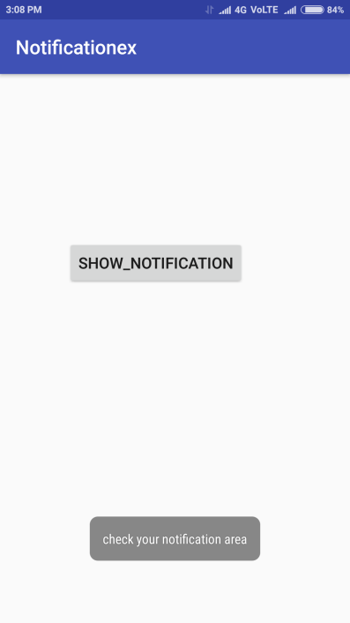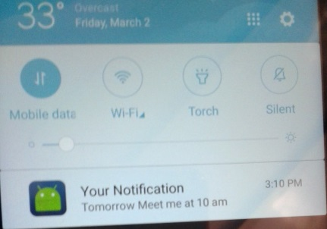

Practical No 9

Aim: Create an android application to connect to Internet and use BroadCast Receiver

Description:

1. BR: **Broadcast Receivers**simply respond to broadcast messages from other applications or from the system itself. These messages are sometime called events or intents.
2. Why do we need a Broadcast Receiver: In android OS Different type of event occurs

* Batterylow
* Wifi availability
* Bluetooth device connected
* Incoming call
* Incoming message
* Charger connected/disconnected

---Example:In case Batterlow event happen you need to stop the application ,if any app use datasource it will drain more battery

--- We want mechanism to listen this type of events ,this mechanism is called listener and technically it is called BR

---BR Listen listen to event that are register to it

----To register Broadcast Recevicer(BR) is either in manifest file or through code

ConnectivityManager.***TYPE_MOBILE***: it checks whether internet is connected or not

ConnectivityManager.***TYPE_WIFI:i***t checks whether wifi is connected or not

An **intent filter** specifies the types of intents to which an activity, service, or broadcast receiver can respond to .In this case, the system broadcasts android.net.conn.CONNECTIVITY_CHANGE whenever there is a connection change (connected/disconnected).

ni!=**null means it is connected to internet**

Manifest: add permissions

*<?***xml version="1.0" encoding="utf-8"***?>*<**manifest xmlns:android="http://schemas.android.com/apk/res/android"  
 package="com.example.rajesh.broadcastexample"**>  
<**uses-permission android:name="android.permission.INTERNET"**/>  
<**uses-permission android:name="android.permission.ACCESS_NETWORK_STATE"**/>  
  
  
<**application  
 android:allowBackup="true"  
 android:icon="@mipmap/ic_launcher"  
 android:label="@string/app_name"  
 android:roundIcon="@mipmap/ic_launcher_round"  
 android:supportsRtl="true"  
 android:theme="@style/AppTheme"**>  
<**activity android:name=".MainActivity"**>  
<**intent-filter**>  
<**action android:name="android.intent.action.MAIN"** />  
  
<**category android:name="android.intent.category.LAUNCHER"** />  
</**intent-filter**>  
</**activity**>  
</**application**>  
  
</**manifest**>

CheckInternet.java

**public class** CheckInternet **extends** BroadcastReceiver  
{  
 @Override  
**public void** onReceive(Context context, Intent intent) {  
  
 }  
**public void** isNetworkAvailable(Context c,**int**[]type)  
 {  
 ConnectivityManager cm=(ConnectivityManager)c.getSystemService(Context.***CONNECTIVITY_SERVICE***);  
**for**(**int** t:type) {  
 NetworkInfo ni = cm.getNetworkInfo(t);  
**if**(ni!=**null**&&ni.getState()==NetworkInfo.State.***CONNECTED***)  
 {  
 Toast.*makeText*(c,ni.getTypeName() +**"connected"**, Toast.***LENGTH_LONG***).show();  
 }  
**else**Toast.*makeText*(c, ni.getTypeName()+**"not connected"**, Toast.***LENGTH_LONG***).show();  
 }  
}

MainActivity.java

**package** com.example.rajesh.broadcastexample;  
  
**import** android.content.BroadcastReceiver;  
**import** android.content.Context;  
**import** android.content.Intent;  
**import** android.content.IntentFilter;  
**import** android.net.ConnectivityManager;  
**import** android.support.v7.app.AppCompatActivity;  
**import** android.os.Bundle;  
  
**public class** MainActivity **extends** AppCompatActivity {  
 CheckInternet **chk**;  
 BroadcastReceiver **br**;  
  
 @Override  
**protected void** onCreate(Bundle savedInstanceState) {  
**super**.onCreate(savedInstanceState);  
 setContentView(R.layout.***activity_main***);  
 IntentFilter in=**new** IntentFilter(**"android.net.conn.CONNECTIVITY_CHANGE"**);  
  
**chk**=**new** CheckInternet();  
**br**=**new** BroadcastReceiver() {  
  
  
 @Override  
**public void** onReceive(Context context, Intent intent) {  
**try** {  
**int**[] t = {ConnectivityManager.***TYPE_MOBILE***, ConnectivityManager.***TYPE_WIFI***};  
**chk**.isNetworkAvailable(context, t);  
  
 }  
**catch** (Exception e)  
 {e.printStackTrace();  
  
 }  
  
  
 }  
 };  
 registerReceiver(**br**,in);  
  
  
 }  
}

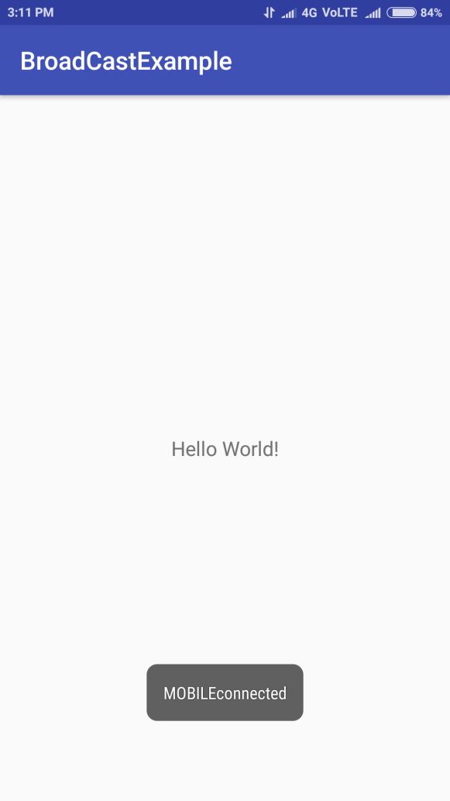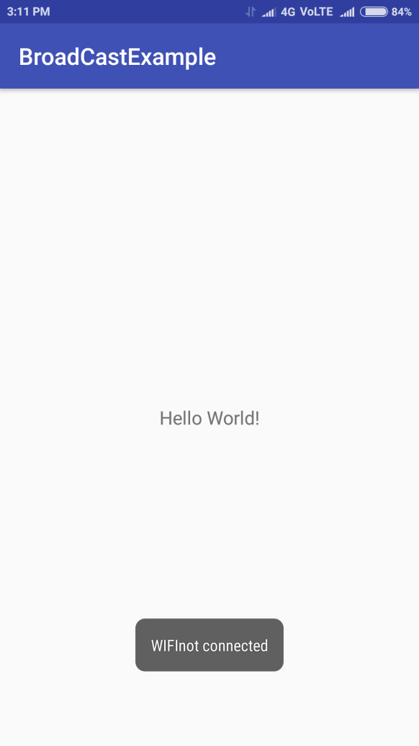

Practical No 10

Aim: Create an android application to save the Employee data in database

Description:

* **SQLite** is an **open-source relational database** i.e. used to perform database operations on android devices such as storing, manipulating or retrieving persistent data from the database.
* It is embedded in android bydefault. So, there is no need to perform any database setup or administration task
* . In order to access this database, you don't need to establish any kind of connections for it like JDBC,ODBC e.t.c
* **Database - Package**

The main package is android.database.sqlite that contains the classes to manage your own databases

* **Database – Creation**

**sSQLiteOpenHelper** class provides the functionality to use the SQLite database

For performing any database operation, you have to provide the implementation of **onCreate()** and **onUpgrade()** methods of SQLiteOpenHelper class

* **insert()-**method to insert a row into the database.

Program

Activity_main.xml

*<?***xml version="1.0" encoding="utf-8"***?>*<**RelativeLayout xmlns:android="http://schemas.android.com/apk/res/android"  
xmlns:app="http://schemas.android.com/apk/res-auto"  
xmlns:tools="http://schemas.android.com/tools"  
android:layout_width="match_parent"  
android:layout_height="match_parent"  
tools:context="com.example.zaheer.data1.MainActivity"**>  
  
<**EditText  
android:id="@+id/editText"  
android:layout_width="wrap_content"  
android:layout_height="wrap_content"  
android:ems="10"  
android:inputType="number"  
android:hint="enter empid"  
tools:layout_editor_absoluteX="16dp"  
tools:layout_editor_absoluteY="67dp"** />  
  
  
<**EditText  
android:id="@+id/editText2"  
android:layout_width="wrap_content"  
android:layout_height="wrap_content"  
android:ems="10"  
android:inputType="textPersonName"  
android:hint="enter name"  
tools:layout_editor_absoluteX="16dp"  
tools:layout_editor_absoluteY="141dp"  
android:layout_below="@+id/editText"  
android:layout_alignParentStart="true"  
android:layout_marginTop="44dp"** />  
  
<**EditText  
android:id="@+id/editText3"  
android:layout_width="wrap_content"  
android:layout_height="wrap_content"  
android:layout_marginTop="56dp"  
android:ems="10"  
android:inputType="number"  
android:hint="enter salary "  
android:layout_below="@+id/editText2"  
android:layout_alignEnd="@+id/editText2"  
android:layout_marginEnd="18dp"** />  
  
<**Button  
android:id="@+id/button"  
android:layout_width="wrap_content"  
android:layout_height="wrap_content"  
android:layout_alignEnd="@+id/editText3"  
android:layout_alignParentBottom="true"  
android:layout_marginBottom="61dp"  
android:layout_marginEnd="18dp"  
android:text="Save"** />  
  
</**RelativeLayout**>

DatabaseHelper.java

package in.rahultyagi.data;  
  
**import** android.content.ContentValues;  
  
**import** android.content.ContentValues;  
**import** android.content.Context;  
**import** android.database.Cursor;  
**import** android.database.sqlite.SQLiteDatabase;  
**import** android.database.sqlite.SQLiteOpenHelper;  
  
  
**public class** DatabaseHelper **extends** SQLiteOpenHelper {  
  
**public static final** String ***DATABASE_NAME*** = **"Employee"**;  
**public static final** String ***TABLE_NAME*** = **"employee_table"**;  
**public static final** String ***Col_1*** = **"ID"**;  
**public static final** String ***Col_2*** = **"NAME"**;  
**public static final** String ***Col_3*** = **"SALARY"**;  
  
**public** DatabaseHelper(Context context) {  
**super**(context, ***DATABASE_NAME***, **null**, 1);  
 SQLiteDatabase db = **this**.getWritableDatabase();  
  
  
 }  
  
@Override  
**public void** onCreate(SQLiteDatabase db) {  
  
 db.execSQL(**"create table "** + ***TABLE_NAME*** + **"(ID INTEGER ,NAME TEXT,SALARY FLOAT )"**);  
 }  
  
@Override  
**public void** onUpgrade(SQLiteDatabase db, **int** oldVersion, **int** newVersion)  
 {  
 db.execSQL(**"DROP TABLE "** + ***TABLE_NAME***);  
 onCreate(db);  
 }  
  
**public boolean** insertData(**int** empid, String empname, **float** empsal)  
 {  
  
 SQLiteDatabase db = **this**.getWritableDatabase();  
 ContentValues contentvalue = **new** ContentValues();  
 contentvalue.put(***Col_1***, empid);  
 contentvalue.put(***Col_2***, empname);  
 contentvalue.put(***Col_3***, empsal);  
  
  
**long** result = db.insert(***TABLE_NAME***, **null**, contentvalue);  
  
  
**if** (result == -1)  
  
**return false**;  
**else  
 return true**;  
 }  
  
  
  
}

MainActivity.java

package in. rahultyagi.data;

**import** android.support.v7.app.AppCompatActivity;  
**import** android.os.Bundle;  
  
  
**import** android.view.View;  
**import** android.widget.Button;  
**import** android.widget.EditText;  
**import** android.widget.Toast;  
  
**import** java.io.IOException;  
  
**public class** MainActivity **extends** AppCompatActivity {  
 EditText **empId**, **empName**, **empSalary**;  
 Button **submit**;  
 DatabaseHelper **mydb**;  
@Override  
**protected void** onCreate(Bundle savedInstanceState) {  
**super**.onCreate(savedInstanceState);  
 setContentView(R.layout.activity_main);  
**mydb** = **new** DatabaseHelper(**this**);  
**empId** = (EditText) findViewById(R.id.***editText***);  
**empName** = (EditText) findViewById(R.id.***editText2***);  
**empSalary** = (EditText) findViewById(R.id.***editText3***);  
**submit** = (Button) findViewById(R.id.***button***);

**submit**.setOnClickListener(**new** View.OnClickListener() {  
@Override  
**public void** onClick(View arg0) {  
  
**try** {  
  
 addEmp();  
  
 } **catch** (IOException e) {  
 e.printStackTrace();  
 }  
  
  
 }  
 });  
  
  
  
}  
  
**private void** addEmp() **throws** IOException {  
  
  
**if** (**empId**.getText().toString().equalsIgnoreCase(**""**)) {  
 Toast.*makeText*(getApplicationContext(), **"plz enter EmpId"**, Toast.***LENGTH_LONG***).show();  
 } **else if** (**empName**.getText().toString().equalsIgnoreCase(**""**)) {  
  
 Toast.*makeText*(getApplicationContext(), **"plz enter EmpName"**, Toast.***LENGTH_LONG***).show();  
 } **else if** (**empSalary**.getText().toString().equalsIgnoreCase(**""**)) {  
  
 Toast.*makeText*(getApplicationContext(), **"plz enter EmpSalary"**, Toast.***LENGTH_LONG***).show();  
  
 } **else** {  
  
 String s1 = **empId**.getText().toString();  
**int** eid = Integer.*parseInt*(s1);  
 String s2 = **empName**.getText().toString();  
 String s3 = **empSalary**.getText().toString();  
**float** sal = Float.*parseFloat*(s3);  
**boolean** in = **mydb**.insertData(eid, s2, sal);  
**if** (in == **true**) {  
 Toast.*makeText*(MainActivity.**this**, **"1 record inserted"**, Toast.***LENGTH_SHORT***).show();  
 } **else**Toast.*makeText*(MainActivity.**this**, **"record not inserted"**, Toast.***LENGTH_SHORT***).show();  
  
 }  
  
}

}

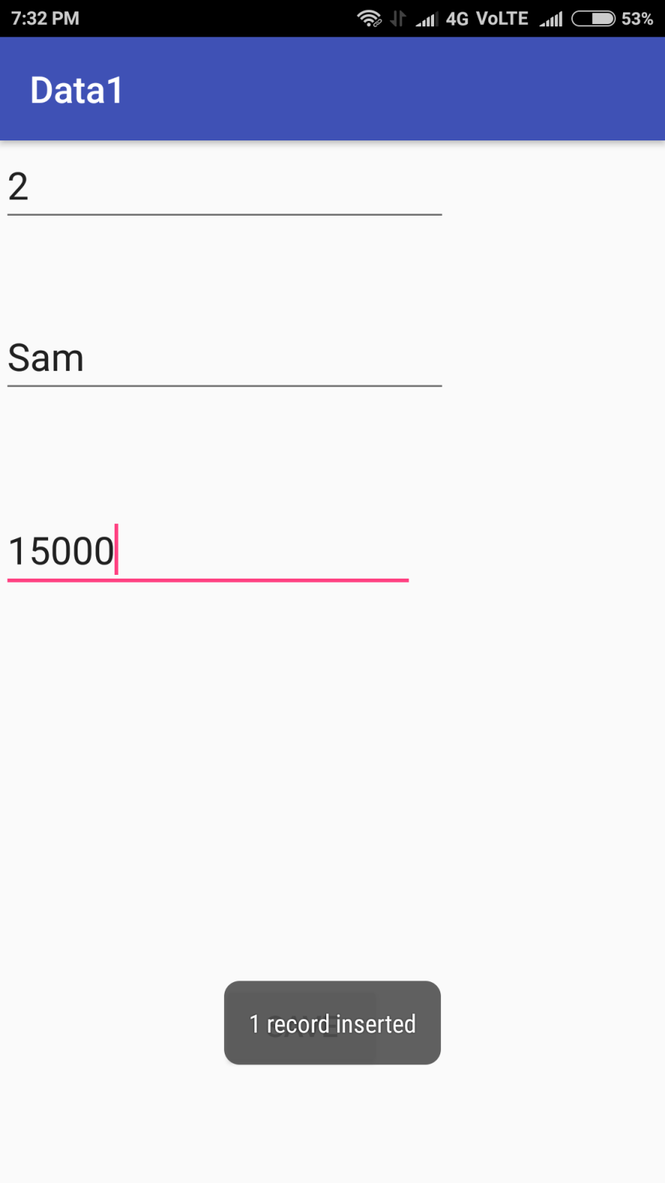

**Practical -12**

**Aim:** Create a table login (username ,password) insert record to it ,Fetch Records and check whether its correct or not.

**Activity_main.xml**

<**RelativeLayoutxmlns:android="http://schemas.android.com/apk/res/android"  
xmlns:tools="http://schemas.android.com/tools" android:layout_width="match_parent"  
android:layout_height="match_parent" android:paddingLeft="@dimen/activity_horizontal_margin"  
android:paddingRight="@dimen/activity_horizontal_margin"  
android:paddingTop="@dimen/activity_vertical_margin"  
android:paddingBottom="@dimen/activity_vertical_margin" tools:context=".MainActivity"  
android:id="@+id/R"**>  
  
<**TextView  
android:layout_width="wrap_content"  
android:layout_height="wrap_content"  
android:text="Enter username"  
android:id="@+id/luser"  
android:layout_alignParentTop="true"  
android:layout_alignParentStart="true"  
android:layout_marginTop="34dp"** />  
  
<**TextView  
android:layout_width="wrap_content"  
android:layout_height="wrap_content"  
android:text="Enter Password"  
android:id="@+id/lpass"  
android:layout_below="@+id/luser"  
android:layout_alignParentStart="true"  
android:layout_marginTop="54dp"** />  
  
<**EditText  
android:layout_width="wrap_content"  
android:layout_height="wrap_content"  
android:id="@+id/user"  
android:layout_alignBottom="@+id/luser"  
android:layout_centerHorizontal="true"** />  
  
<**EditText  
android:layout_width="wrap_content"  
android:layout_height="wrap_content"  
android:id="@+id/pass"  
android:layout_alignTop="@+id/lpass"  
android:layout_centerHorizontal="true"** />  
  
<**Button  
android:layout_width="wrap_content"  
android:layout_height="wrap_content"  
android:text="login"  
android:id="@+id/button"  
android:layout_below="@+id/pass"  
android:layout_alignParentStart="true"  
android:onClick="login_fun"** />  
  
<**Button  
android:layout_width="wrap_content"  
android:layout_height="wrap_content"  
android:text="Register"  
android:id="@+id/button2"  
android:layout_below="@+id/pass"  
android:layout_centerHorizontal="true"  
android:onClick="register"** />  
</**RelativeLayout**>

**MyDatabase.java**

**package** com.example.msc.myapplication;  
  
**import** android.content.Context;  
**import** android.database.sqlite.SQLiteDatabase;  
**import** android.database.sqlite.SQLiteOpenHelper;  
  
**public class** MyDatabase**extends** SQLiteOpenHelper {  
  
**public** MyDatabase(Context context)  
 {  
**super**(context,**"logindb"**,**null**,1);  
 }  
@Override  
**public void** onCreate(SQLiteDatabasedb)  
 {  
 String str=**"create table login(username text,password text)"** ;  
db.execSQL(str);  
  
 }  
@Override  
**public void** onUpgrade(SQLiteDatabasedb,**int**oldVersion,**int**newVersion)  
 {  
 String str=**"drop table if exists login"**;  
db.execSQL(str);  
onCreate(db);  
 }  
}

**MainActivity. Java**

**package** com.example.msc.myapplication;  
  
**import** android.app.Activity;  
**import** android.database.Cursor;  
**import** android.database.sqlite.SQLiteDatabase;  
**import** android.database.sqlite.SQLiteException;  
**import** android.os.Bundle;  
**import** android.view.Menu;  
**import** android.view.MenuItem;  
**import** android.view.View;  
**import** android.widget.EditText;  
**import** android.widget.Toast;  
  
  
**public class** MainActivity**extends** Activity {  
MyDatabase**mdb**;  
SQLiteDatabase**db**;  
EditText**user**,**pass**;  
 String **u**, **p**;  
  
  
@Override  
**protected void** onCreate(Bundle savedInstanceState) {  
**super**.onCreate(savedInstanceState);  
setContentView(R.layout.***activity_main***);  
**mdb**= **new** MyDatabase(**this**);  
**user** = (EditText) findViewById(R.id.***user***);  
**pass** = (EditText) findViewById(R.id.***pass***);  
  
 }  
**public void** login_fun(View view)  
 {  
**u**=**user**.getText().toString();  
**p**=**pass**.getText().toString();  
**db**=**mdb**.getReadableDatabase();  
 String str=**"select * from login where username='"**+**u**+**"'and password ='"**+**p**+**"'"**;  
**try** {  
 Cursor c = **db**.rawQuery(str, **null**);  
**while** (c.moveToNext()) {  
Toast.*makeText*(**this**, **"user ="** + c.getString(0) + **"pass ="** + c.getString(1), Toast.***LENGTH_SHORT***).show();  
  
 }  
**if** (!c.moveToNext()) {  
Toast.*makeText*(**this**, **"Either Username, password is wrong or user does not exist"**, Toast.***LENGTH_SHORT***).show();  
  
  
 } **else** {  
Toast.*makeText*(**this**, **"Welcome user"** + **u**, Toast.***LENGTH_SHORT***).show();  
  
 }  
 }  
**catch**(SQLiteException e)  
 {  
e.printStackTrace();  
  
 }  
  
  
 }  
**public void** register(View view)  
 {  
**u**=**user**.getText().toString();  
**p**=**pass**.getText().toString();  
 String str=**"insert into login values('"**+**u**+**"','"**+**p**+**"')"**;  
**db**=**mdb**.getWritableDatabase();  
**db**.execSQL(str);  
Toast.*makeText*(**this**,**"user"** +**u**+ **" registered"** , Toast.***LENGTH_SHORT***).show();  
  
  
 }  
}

**Output:**

